CS 340 Project Two
Christina Frediani
October 24, 2026

Project Overview
For this project, I created an interactive dashboard for Grazioso Salvare, an organization that identifies dogs for search-and-rescue training. The goal was to make it easier for users to search animal shelter records and find dogs that meet specific training requirements.
I used the MongoDB database and CRUD Python module from Project One and built on the dashboard I started in Module Six. The finished dashboard includes rescue filters, an interactive data table, a pie chart, and a map showing animal locations.
Dashboard Functionality
The dashboard allows users to filter dogs based on three rescue categories: Water Rescue, Mountain or Wilderness Rescue, and Disaster or Individual Tracking. Each category uses specific breed, sex, and age requirements provided by Grazioso Salvare.
The Reset option returns the dashboard to the complete, unfiltered dataset.
The data table allows users to sort, filter, and select animal records. The pie chart shows the distribution of breeds in the selected results, while the geolocation map displays the location of the selected animal. Clicking a marker on the map also displays the animal's name.
I included the Grazioso Salvare logo and my name to meet the dashboard's branding requirements.
Tools and Technologies
I used several tools to complete this project.
- MongoDB: Stores the animal shelter records and allows the dashboard to retrieve information using database queries. Its document-based structure works well with Python.
- Python and PyMongo: Connect the application to MongoDB through the CRUD module created in Project One.
- Dash: Provides the dashboard interface and callbacks that connect the filters, table, and charts.
- Pandas: Organizes the MongoDB records into DataFrames so they can be displayed and analyzed.
- Plotly Express: Creates the interactive pie chart showing animal breed distributions.
- Dash Leaflet: Displays animal locations on the interactive map.
- Jupyter Lab and Codio: Provided the environment where I developed and tested the dashboard.
The application follows the Model-View-Controller (MVC) design pattern. MongoDB serves as the model, the dashboard components provide the view, and the Dash callbacks work as the controller by responding to user selections and updating the displayed information.
Development Process
I started by reviewing the Dashboard Specifications Document to understand what Grazioso Salvare needed.
Next, I connected the dashboard to MongoDB using my existing CRUD Python module. I reused the interactive data table and geolocation map from Module Six, then added radio buttons for the different rescue categories.
I created MongoDB queries using the required breeds, sex classifications, and age ranges. I also added a pie chart to show the distribution of animal breeds.
After testing the dashboard, I made a few adjustments to improve its appearance and functionality, including making the pie chart easier to read.
Testing and Results
I tested the dashboard by selecting each rescue category and checking that the data table, pie chart, and map updated.
The Water Rescue filter displayed matching Labrador Retriever Mix records. The Mountain or Wilderness Rescue filter returned several breeds, including German Shepherds, Siberian Huskies, Alaskan Malamutes, and Rottweilers.
The Disaster or Individual Tracking filter displayed Bloodhounds, German Shepherds, and Rottweilers. I also tested Reset and confirmed that the original unfiltered data returned.
I tested the map by selecting different animals and confirming that the marker moved to their locations. The marker also displayed additional information when hovered over or clicked.
The following screenshots show the dashboard during testing.

Screenshot 1: Initial Dashboard
Shows the starting dashboard with the complete dataset, filtering options, pie chart, and geolocation map.

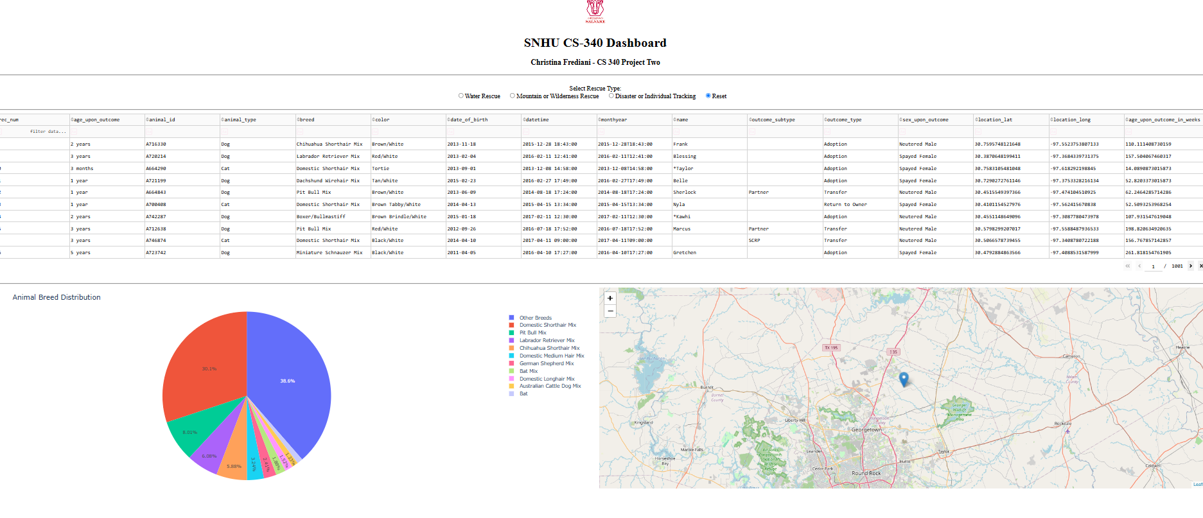
Screenshot 2: Water Rescue
Shows the Water Rescue filter and the updated data table and charts.

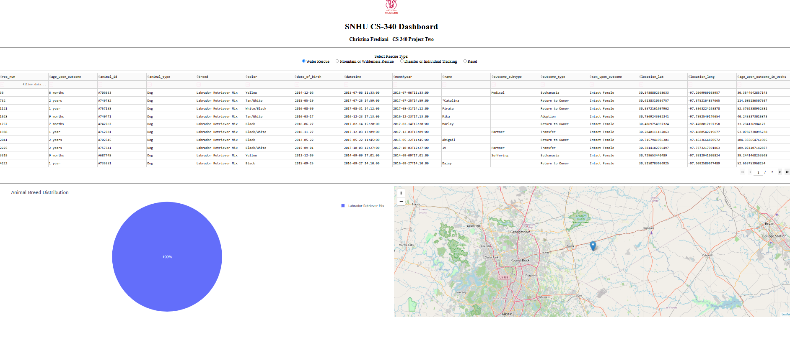
Screenshot 3: Mountain or Wilderness Rescue
Shows the results for dogs matching the Mountain or Wilderness Rescue requirements.
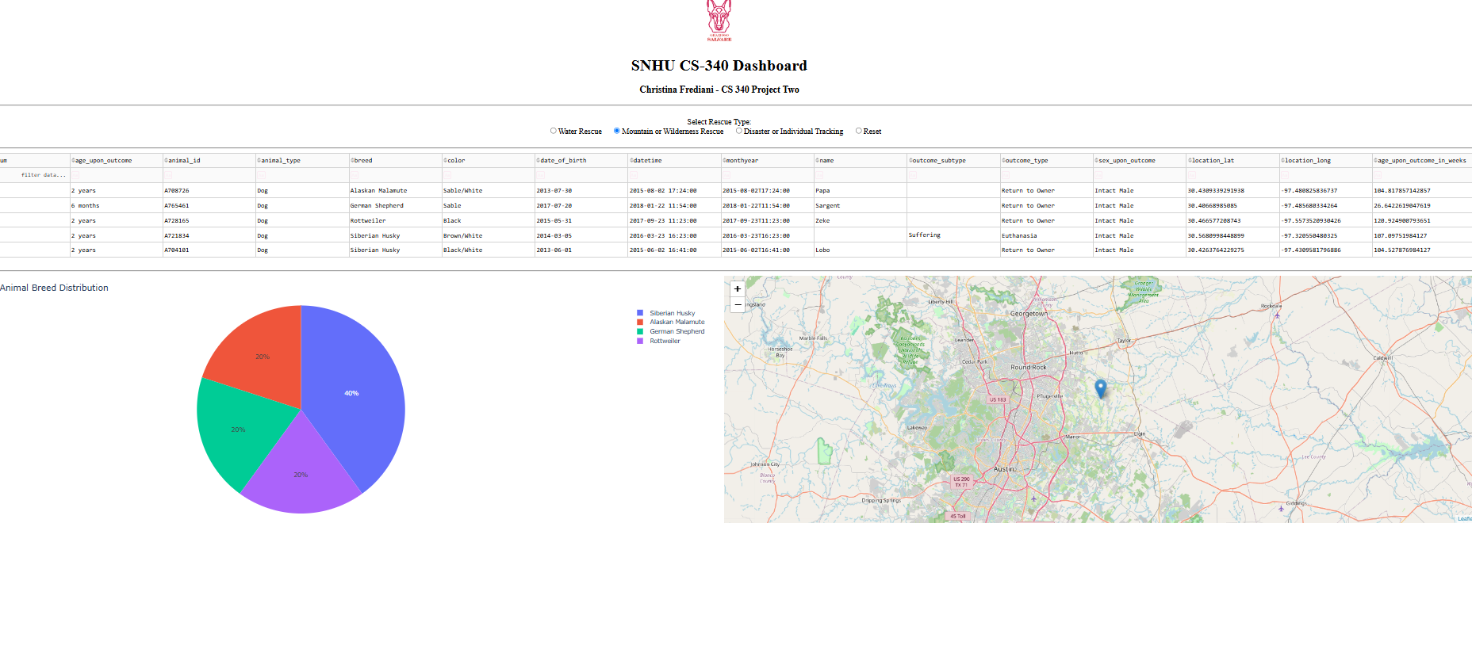
Screenshot 4: Disaster or Individual Tracking
Shows the filtered results and updated visualizations for Disaster or Individual Tracking.

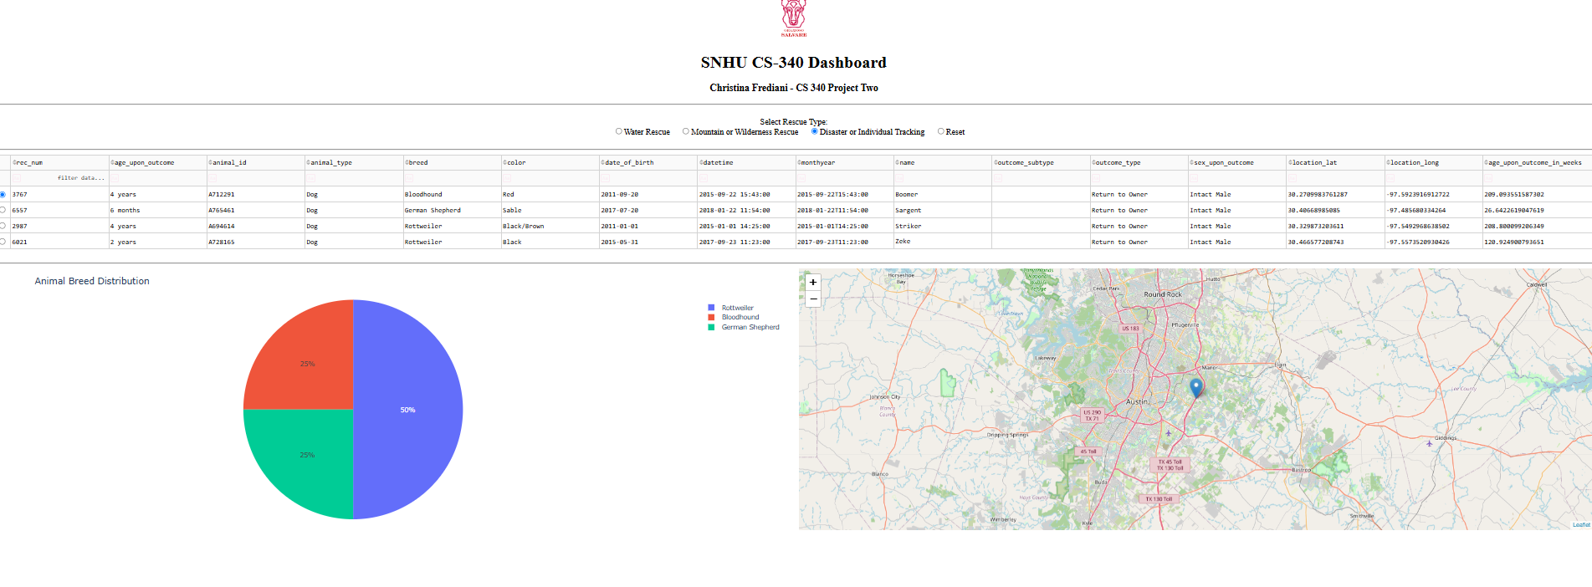

Screenshot 5: Reset
Shows the dashboard returning to its original unfiltered state.

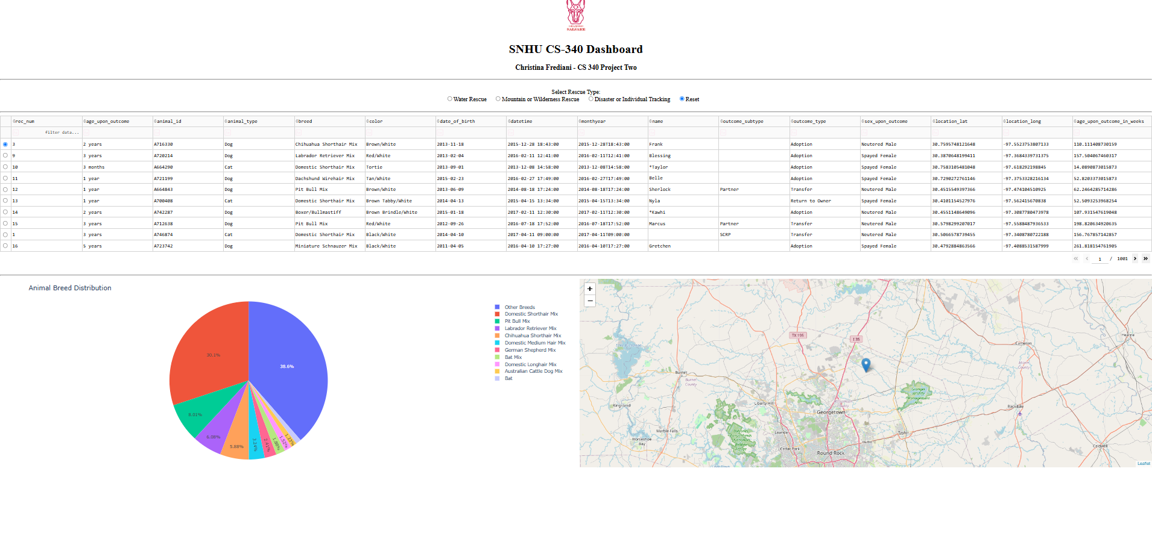
Challenges and Solutions
One challenge I encountered was getting the geolocation map to update correctly when selecting different animals. I had to adjust the callback code and test the row-selection settings before the map worked as expected.
Another issue was the pie chart. When displaying the entire dataset, there were too many breeds, making the chart difficult to read. I corrected this by displaying the ten most common breeds and grouping the remaining breeds into an Other Breeds category.
Working through these issues helped me better understand how Dash callbacks work and why testing each part of an application is important.

How to Run the Dashboard
To run the project, MongoDB must be available with the Austin Animal Center Outcomes dataset imported into the aac database and animals collection.
The ProjectTwoDashboard.ipynb notebook, CRUD_Python_Module.py file, and Grazioso Salvare logo image should be placed in the same working directory.
The required Python libraries must also be installed, including Dash, JupyterDash, PyMongo, Pandas, Plotly, and Dash Leaflet.
After configuring the MongoDB connection with valid credentials, open the notebook in Jupyter Lab and run the code. Once the dashboard starts, open the provided link to view the application.
Users can select a rescue category to filter the data, select individual animals to view their locations, or choose Reset to display all records.
Conclusion
This project helped me better understand how MongoDB, Python, and Dash work together to create an interactive application. I was able to build on my previous work, add new dashboard features, and troubleshoot issues along the way.
The finished dashboard provides Grazioso Salvare with a way to search animal records and visualize information that could help identify dogs for rescue training.

References
- Southern New Hampshire University. CS 340 Dashboard Specifications Document.
- Southern New Hampshire University. CS 340 Dashboard Sample Walkthrough.
- Dash Documentation: https://dash.plotly.com/
- Dash DataTable: https://dash.plotly.com/datatable
- MongoDB Documentation: https://www.mongodb.com/docs/
- Dash Leaflet Documentation: https://dash-leaflet-docs.onrender.com/
- Pandas Documentation: https://pandas.pydata.org/docs/

